**HCAD Midterm and Course Withdrawal Guide**

The Midterm period is the perfect opportunity to take stock of where you are in your courses. By this point, you should have completed about half of the projects, assignments, and/or exams for your courses.

This is a good time to look back on the grades you’ve received so far, touch base with your instructors on how your grades stand in each course, and to coordinate your remaining assignments, etc., to maintain or improve your grades for the remainder of the semester.

**Midterm Warnings**

Midterm warnings are usually issued to students who are at risk of receiving a grade lower than a “C” in a course.

Receiving a Midterm Warning from your instructor does NOT necessarily mean that you are failing the class! It is only an assessment to help students better understand the shortcomings impacting their grades, and the steps they can take to improve their academic performance and final grade for the semester.

If you received a Midterm Warning, please read that warning carefully and have a discussion with your instructor right away (in person, online, or via email) to make sure you fully understand 1) where you stand in the course, and 2) your options for improving your grades and successfully completing the class..

If your instructor recommends that you withdraw from their course, please contact [HCADadvising@njit.edu](mailto:HCADadvising@njit.edu) and your designated HCAD advisor right away!

**Course Withdrawals**

Course withdrawals are an appropriate option for students who are unable to successfully complete a class. While withdrawals do not negatively affect GPA or Academic Standing, it may impact other aspects of your academic progress.

Before withdrawing from a course, it is important that you **have a discussion (verbally or via email) with your HCAD advisor.** This is to ensure that you are aware of how dropping the course(s) may impact your academic progress. By discussing these issues with your HCAD advisor first, you can make a fully informed decision.

Please keep in mind, once you’ve withdrawn from a course, there is no way to re-add the class to your schedule. If you choose to withdraw without advisor input or against advisor recommendation, **it is ultimately your responsibility to address any potential impact** the course withdrawal may have on your academic status and/or degree progress.

Students can withdraw from a course directly in their student account under **Banner Registration Self-Service** by following the steps below:

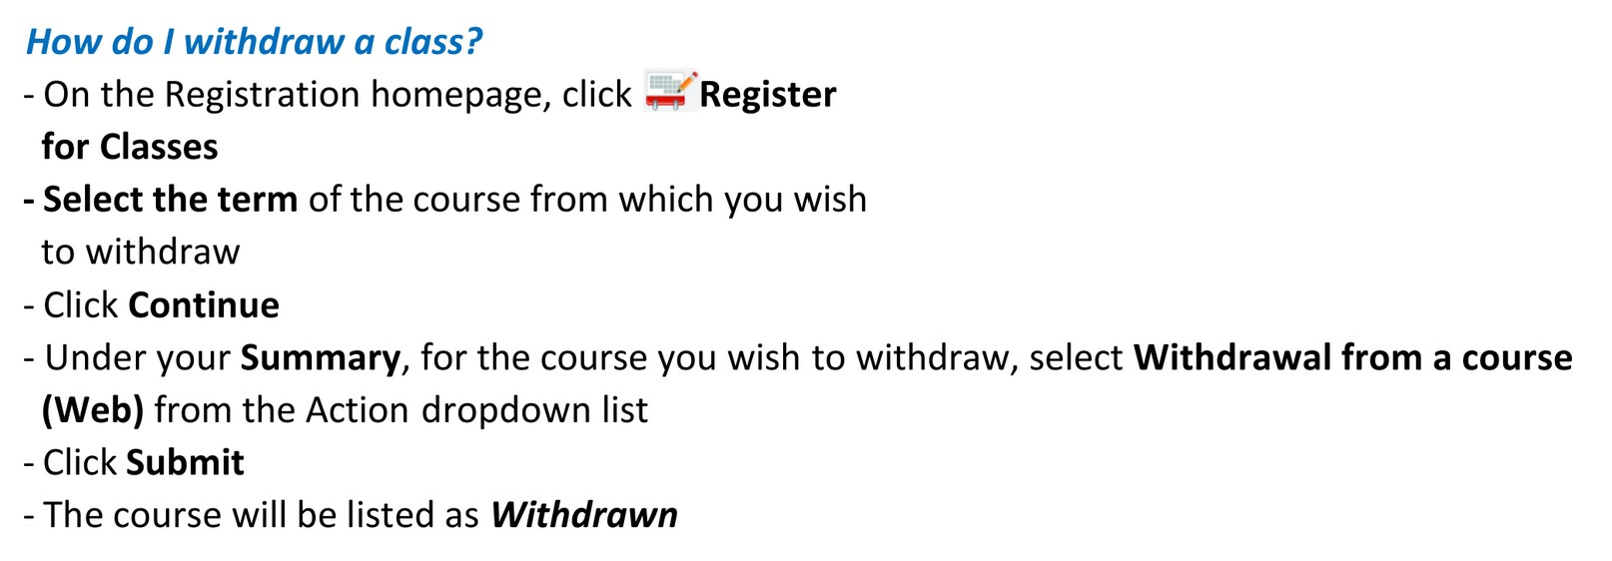

Please note and **keep track of the Course Withdrawal deadline on the Registrar’s** [**Academic Calendar page**](https://www5.njit.edu/registrar/calendars/) to make sure you have ample opportunity to weigh this option and consult with your HCAD advisor BEFORE that date. Once that Course Withdrawal deadline has passed, you will not be able to withdraw from any courses.

Below are several key factors to keep in mind when deciding whether or not to withdraw from a course. You can still withdraw, even if you face one or more of the factors below:

**1. Full Time Status & Financial Aid**  
The minimum number of credits needed on your schedule for undergraduate full time status is 12 credits. If the course withdrawal will drop your schedule below 12 credits, this could affect the financial aid you receive.

Please contact the [Student Financial Aid Services Office](https://www.njit.edu/financialaid/contact-us) directly to determine if/how this may impact your financial aid for the semester and year.

**2. Visa Status (International Students)**  
For International Students, a course withdrawal could significantly impact their student visa status. International students must maintain a minimum full time course load of 12 credits, 9 credits of which must be in-classroom (i.e., in-person) courses. There is a two-step process for international students to withdraw from classes.

International students must first contact their HCAD advisor for written (email) approval to withdraw from the course. Once approved, they must then complete the online [Withdrawal Request Form](https://www.njit.edu/global/withdrawing-from-a-course) from the [Office of Global Initiatives](https://www.njit.edu/global/contact) to complete the course withdrawal.

**3. Academic Standing & GPA**   
The university standard for Good Academic Standing is a minimum CUMULATIVE and TERM GPA of 2.0. Falling below a 2.0 GPA (either Term, CUM, or both) will result in a change to your academic standing (Warning, Probation, Pre-suspension, Academic Suspension).

Course withdrawals will result in a “W” on your transcript in place of a grade, but do not affect the Term or CUM GPA. Withdrawing from a class that you cannot successfully complete could help avoid the impact of a low grade or F on your GPA or academic standing.

**4. Course Pre-requisites**  
HCAD courses are offered in the Fall or Spring semester only (not both) as laid out on your Program Form. If the course you plan to withdraw from is a pre-requisite for a course needed next semester (or next year), the withdrawal would prevent you from taking the next course in the sequence (including studio). This could potentially add an extra semester or year to your studies.

The Pre-Reqs tab in your Program Form details the course pre-requisites and minimum passing grade requirements for all required courses in your curriculum. Please refer to the Pre-Reqs tab in your Program Form and discuss the withdrawal with your HCAD advisor.

**5. Minimum Passing Grade Requirements**  
For some courses, the minimum passing grade for degree progres is a “C.” For studio courses, the minimum requirement is a 2.0 annual studio GPA between the Fall and Spring studios in the same academic year to advance to the next studio year. A course withdrawal could have the same impact on your degree/studio progress as not meeting the minimum grade/GPA requirement. However, a course withdrawal will not affect your GPA.

Again, please check the Pre-Reqs tab in your Program Form for the minimum passing grade requirements for all course requirements in your curriculum.

**6. Course Repetitions**  
Per university policy, students can take the same course up to 4 times total. Taking a course for transfer credit and course withdrawals count toward a course repetition.

If you are on your 4th attempt trying to pass a class, a course withdrawal could be detrimental to your academic progress. Depending on the course, using up all of your allowed attempts (including course withdrawals) may make it impossible to complete a degree at NJIT.

Again, the decision to withdraw from a course is completely yours to make. Just please make sure to discuss any course withdrawals with your HCAD advisor BEFORE you make that decision.

Please also remember to refer to the **Academic Calendar** on the[**Registrar’s Office website**](https://www5.njit.edu/registrar/index.php)for the course withdrawal deadline, office hours, and other important academic dates and information.